Jack Chen
Mr. Richard
Colloquy
2018/4/10
Capstone Project’s Reflection
What’s My General Purpose?
I want to do this project as I want to help those having trouble learning mathematics. My goal is to write a calculus tutorial and then make someone uses it.
What’s My Specific Goals?
I not only want to write a calculus tutorial for AP calculus content, but also a preparation of college calculus and certain test strategy. Besides, I want others to use it and give me a good feedback (which will be quantified by a survey)
Planning and Process:
1. During the execution process, I actually found it difficult to start. I had no idea what a common study guide looked like. So, I referenced AP Barron Calculus and another college-level calculus book.
2. Then I spent a little bit time structuring my tutorial and started writing the tutorial. I decide that my tutorial will have 4 units, and each section of each unit consists of a summary, a problem-solving strategy section, a knowledge-point check section, sample questions section and practice sections.
3. I am writing the tutorial and read college and G11 calculus textbooks. As I read the books, I put some important yet not well-taught knowledge points into my tutorials.
4. I finish the tutorial and edit my tutorial.
5. I design a survey and send it to G11 students through QQ and receive feedback.
Verifications:
My calculus tutorial has already been uploaded to my own website. An image is provided here.
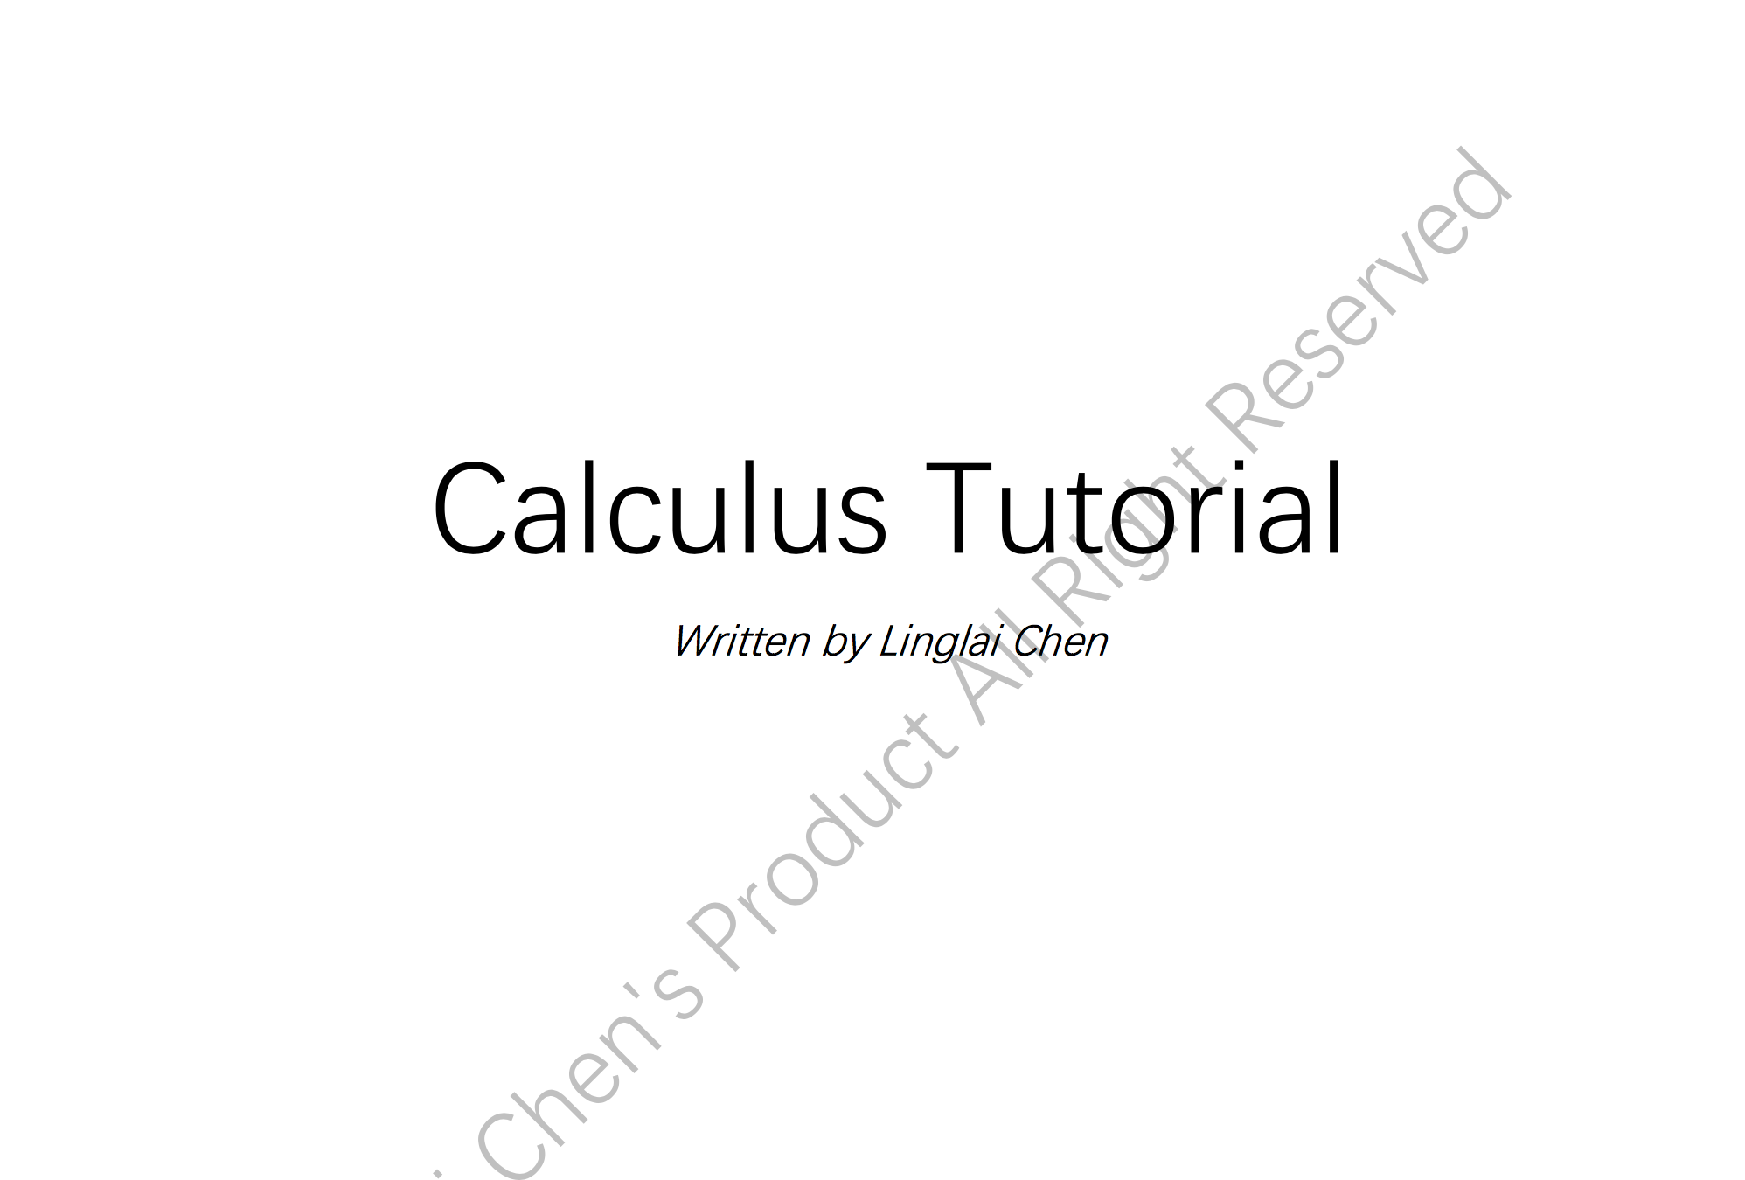
Results:
Now I have finished writing the tutorial and there are two people already use it and grade it. The result is 24/30 and 27/30 respectively. One thing I learned through this project is that you have to always remember the core of your tasks. I was distracted by some calculus textbooks and was amazed that their covers and images were cool. But I did not realize that actually I had only at most 50 hours. Editing the contents were much more important than design of the study guide. Another thing is that even for STEM(science, technology, engineering and math) subjects reading and writing are important skills. During the writing process, I sometimes found hard to explain concepts clearly as well as summarize qualitatively. When I read the college textbook and other referenced materials, I realized how important a fast reading speed was.
References:
- The Calculus Textbook I used
- Paul’s online math notes
- AP Calculus BC Barron
(The links are already provided on my website)

